Clientes

GET - <http://localhost:3000/clientes>

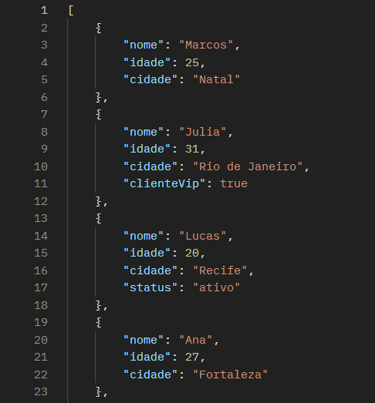

POST - <http://localhost:3000/clientes>

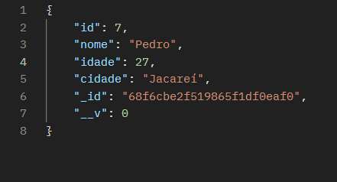

PUT - <http://localhost:3000/clientes>/7

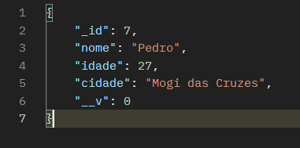

DELETE - <http://localhost:3000/clientes/7>

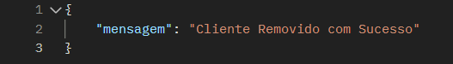

Produtos

GET - <http://localhost:3000/produtos>

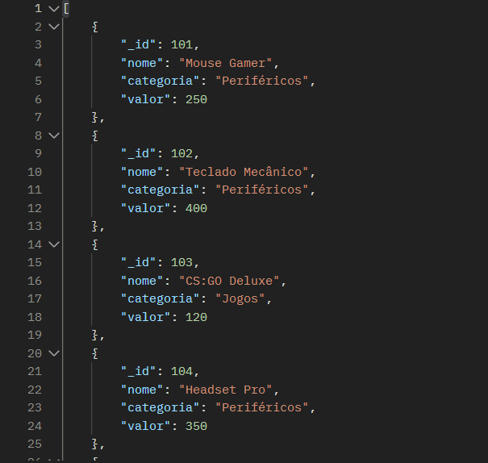

POST - <http://localhost:3000/produtos>

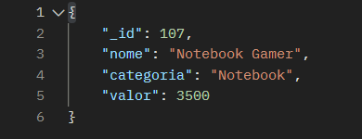

PUT - <http://localhost:3000/produtos/107>

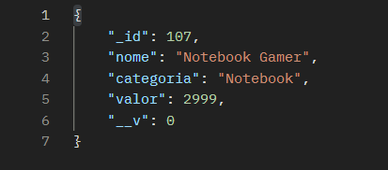

DELETE - <http://localhost:3000/produtos/107>

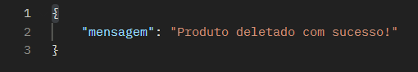

Vendas

GET - <http://localhost:3000/vendas>

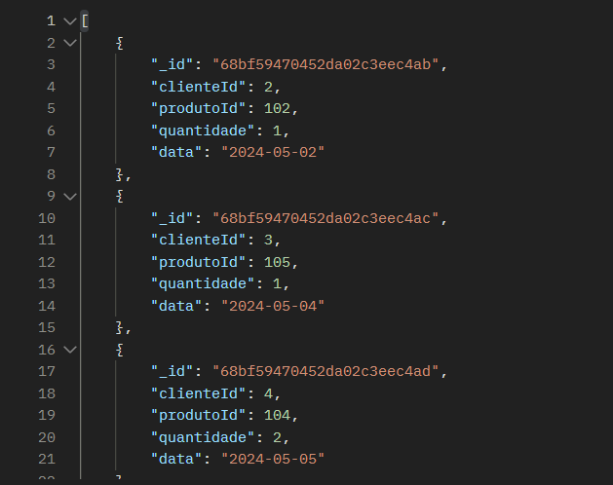

POST - <http://localhost:3000/vendas>

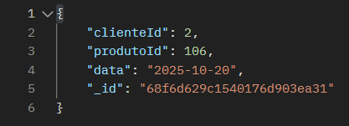

PUT - <http://localhost:3000/vendas/68f6d6d9a78772a1cb3438c4>

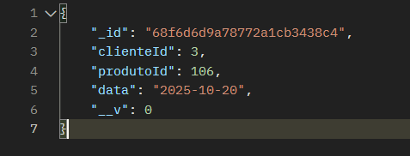

DELETE - <http://localhost:3000/vendas/68f6d6d9a78772a1cb3438c4>

